SMPL: EFS Exhaust Filter Info
Test Script

Template Version Number: 1.0

Document Approval / Review (To be completed pre-execution of Tests)
 | Name & Role | Signature | Date
Author | Tom Rautenbach |  | 28MAY2026
Reviewed
Approved

Version Control
Version | Date | Description of Changes | Author
1.0 | 28MAY2026 | Initial Document | Tom Rautenbach

Referenced Documents
No. | Document Title and ID | Version | Location
1 | SMPL_EFS Exhaust Filter Info XStep Design Specification | 1.0 | Project documentation / controlled repository

Disclaimer
If you are reading a copy of this document (i.e. print out of controlled electronic document or an electronic copy of a wet ink signed paper document) you may be reading an uncontrolled version. Before making updates, please ensure that you are using the latest version of this document and the associated template.

Test Script ID & Version #: | SMPL: EFS Exhaust Filter Info V1 | Test Phase: | Unit Test
Test Name: | SMPL: EFS Exhaust Filter Unit Test
Test Objective: | To verify that the SMPL: EFS Exhaust Filter Info XStep allows the operator to capture Exhaust Filter part information, validates Part No. and Batch values against SAP, populates Description and Expiry output fields, and supports completion using appropriate Performed By and Witnessed By signature controls.
Requirements Tested: | The test confirms that line number, Part No., Description, Batch, Expiry, Port Attached To, Use, Performed By, and Witnessed By fields behave as expected, including validation for Part No. existence, Batch existence, batch/material relationship, and restriction that Batch cannot be entered before Part No. Additionally the ability to deactivate the Tubing Assembly table if not required.

Pre-requisites:
• A valid process order exists in SAP with the SMPL: EFS Exhaust Filter Info XStep assigned through the relevant SiMPL Master Recipe.
• The test user has access to the SiMPL EBR/Fiori application and required SAP authorization for the applicable plant.
• A valid material/part number exists in SAP and has a material description maintained in MAKT.
• An invalid/non-existing material/part number is available for negative validation testing.
• A valid batch exists in SAP for the valid material and has expiry information available in MCH1.
• A batch exists in SAP but is not valid for the entered material for negative validation testing.
• The user signing the Performed By field is an approved user with valid credentials.
• A separate authorized user is available to complete the Witnessed By field.
• At least two Welders ready to assign to the order for use

Set Up Steps: | Data Requirements:
• Create or identify a released process order containing the SMPL: EFS Exhaust Filter Info XStep.  • Confirm the XStep is visible in the applicable EBR phase.  • Prepare test values for Step Reference #, Autoclave Cycle No., Port Attached To, and Use.  • Prepare valid and invalid Part No. values for validation testing.  • Prepare valid, invalid, and material-mismatched Batch values for validation testing.  • Confirm valid signature credentials are available for Performed By and a different Witnessed By user. | • Step Reference # test value.  • Valid Part No. test value that exists in SAP.  • Invalid Part No. test value that does not exist in SAP.  • Valid Batch test value for the entered Part No.  • Invalid Batch test value that does not exist in SAP.  • Batch test value that exists in SAP but is not valid for the entered Part No.  • Port Attached To test value.  • Use field test value.  • Valid Performed By and Witnessed By user credentials.  • Two welders configured as equipment in SAP

System Name & Version #: | DE1 V1 | All pre-requisites satisfied/set up steps completed? |  | Yes
Environment: | DE1
Tester Name: | Thomas Rautenbach | Date Test Commenced: | 03JUN2026 | Run # | 1

Instructions for the Tester:
- Carry out the action described in each step and compare the results achieved with the Expected Result to determine if the step has passed. Record the Pass / Fail status against each step.
- If the Expected Result is not met or an issue is encountered, record the related Test Issue Log (TIL) number in the Pass/Fail column against the relevant step.
- For GxP regulated systems you must document the Actual Result for the step .
- For GxP systems, wherever specifically required by the test script, documentary evidence must be collected and appropriately managed. At your own discretion you may collect additional documentary evidence to support the results achieved.

Step No. | Action / Description | Expected Result | Actual Result | Pass/ Fail  Test Issue Log #
1 | Create and Release a Process Order with the pre-configured SiMPL Master Recipe and the relevant Production Version | Process Order created and Released containing SMPL: EFS Exhaust Filter Info | Process Order created and Released containing SMPL: EFS Exhaust Filter Info | PASS
2 | Open the EBR and navigate to SMPL: EFS Exhaust Filter Info | The EBR for the selected Process Order and Control Recipe opens successfully without any errors and the SMPL: EFS Exhaust Filter Info step is visible | The EBR for the selected Process Order and Control Recipe opens successfully without any errors and the SMPL: EFS Exhaust Filter Info step is visible | PASS
3 | Enter a batch that exists in SAP | Validation popup appears | Validation popup appears | PASS
4 | Discard popup | Popup Discarded | Popup Discarded | PASS
5 | Enter a Part No. that does not exist in SAP | Validation popup appears | Validation popup appears | PASS
6 | Discard Popup | Popup Discarded | Popup Discarded | PASS
7 | Enter a Part No. that does exists in SAP | Value Accepted | Value Accepted | PASS
8 | Enter a Serial Number | Value Accepted | Value Accepted | PASS
9 | Enter a Batch that does exist in SAP but not for the entered material | Validation popup appears | Validation popup appears | PASS
10 | Discard popup | Popup Discarded | Popup Discarded | PASS
11 | Enter a Batch that does exist in SAP for the entered material | -Value Accepted  -Expiry Date populated | -Value Accepted  -Expiry Date populated | PASS
12 | With a single Welder assigned to the order select “Get Welder” | -Welder ID and Description populate automatically | -Welder ID and Description populate automatically | PASS
13 | Assign a second welder to the order and select “Get Welder” | A selection screen appears with the details of both Welders for the user to choose from. | A selection screen appears with the details of both Welders for the user to choose from. | PASS
14 | Select a welder and close the popup | The selected welder ID and Description populate in respective fields | The selected welder ID and Description populate in respective fields | PASS
15 | Select “Get Date” | Installation Date field populates with current system date | Installation Date field populates with current system date | PASS
16 | Enter a value for “Port Attached to” | Value Accepted | Value Accepted | PASS
17 | Sign the Performed by signature | -Table line completed | -Table line completed | PASS
18 | Select No for “Tubing Assembly Required?” | -Tubing Assembly table deactivated | -Tubing Assembly table deactivated | PASS
19 | Select Yes for “Tubing Assembly Required?” | -Tubing Assembly Table Activated | -Tubing Assembly Table Activated | PASS
20 | Enter a batch that exists in SAP | Validation popup appears | Validation popup appears | PASS
21 | Discard popup | Popup Discarded | Popup Discarded | PASS
22 | Enter a Part No. that does not exist in SAP | Validation popup appears | Validation popup appears | PASS
23 | Discard Popup | Popup Discarded | Popup Discarded | PASS
24 | Enter a Part No. that does exists in SAP | Value Accepted | Value Accepted | PASS
25 | Enter a Batch that does exist in SAP but not for the entered material | Validation popup appears | Validation popup appears | PASS
26 | Discard popup | Popup Discarded | Popup Discarded | PASS
27 | Enter a Batch that does exist in SAP for the entered material | -Value Accepted  -Expiry Date populated | -Value Accepted  -Expiry Date populated | PASS
28 | Sign the performed by signature field | -table line completed | -table line completed | PASS
29 | Add a table line | -table line added to both tables  -# column increments correctly | -table line added to both tables  -# column increments correctly | PASS
30 | Deactivate new table rows | -table rows deactivated | -table rows deactivated | PASS
31 | Sign witnessed by signature | Process step completed | Process step completed | PASS

2. 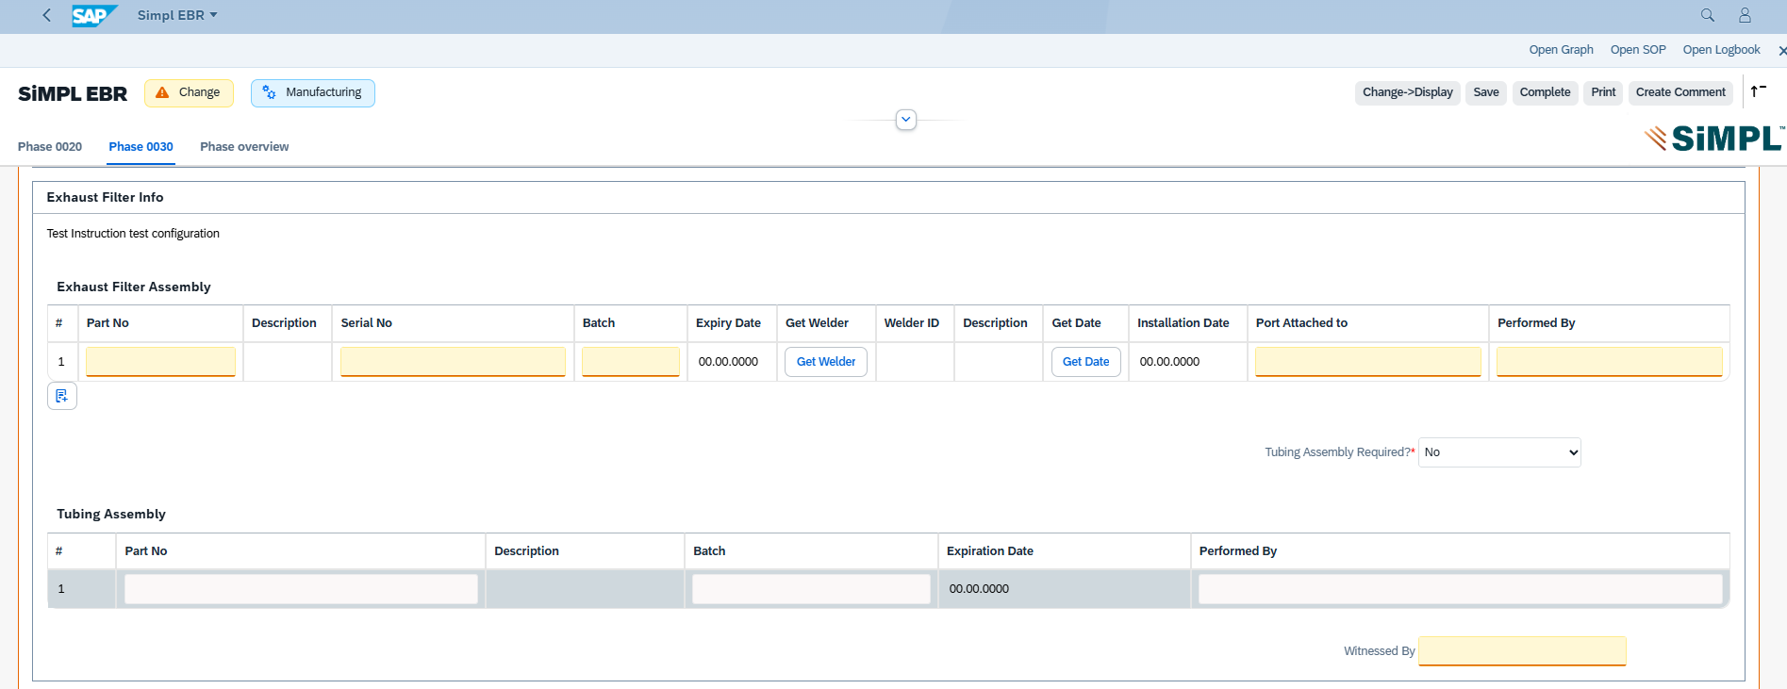

3. 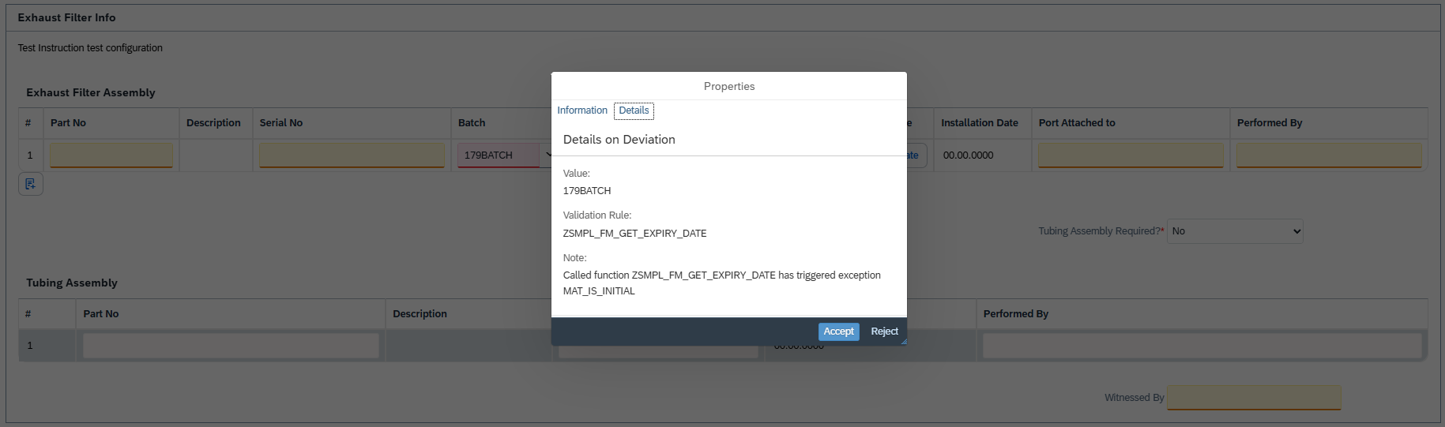

5. 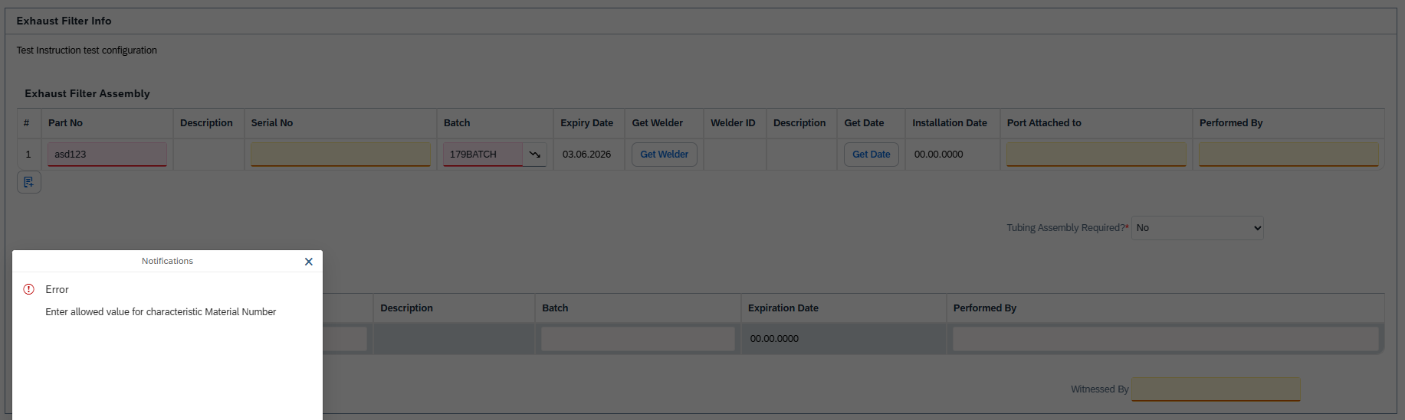

7. 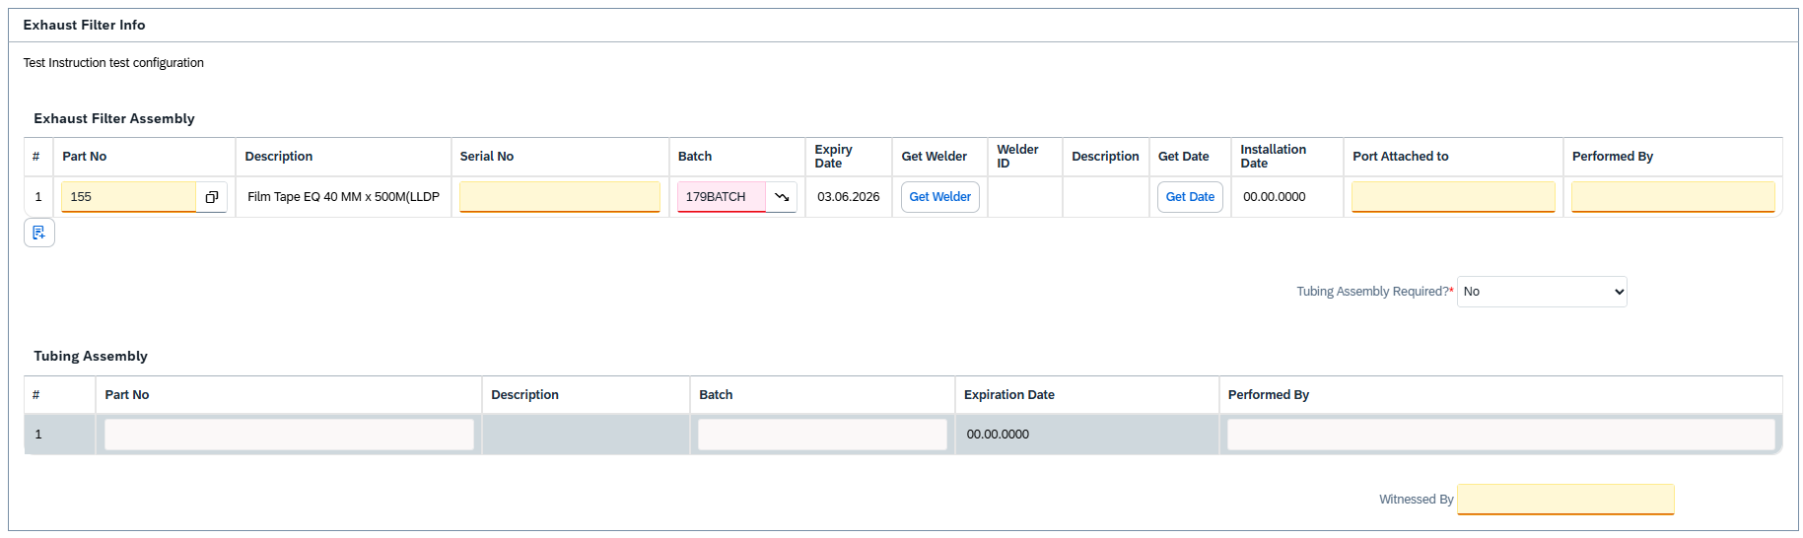

8. 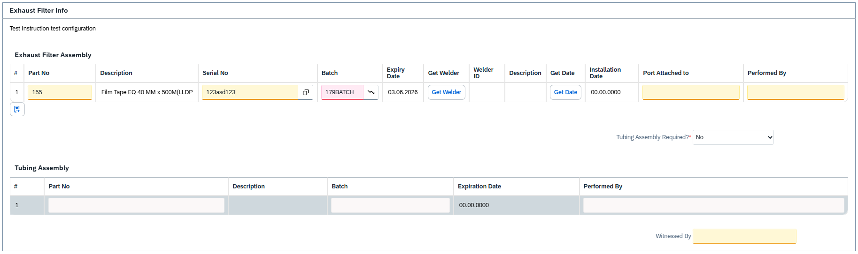

9. 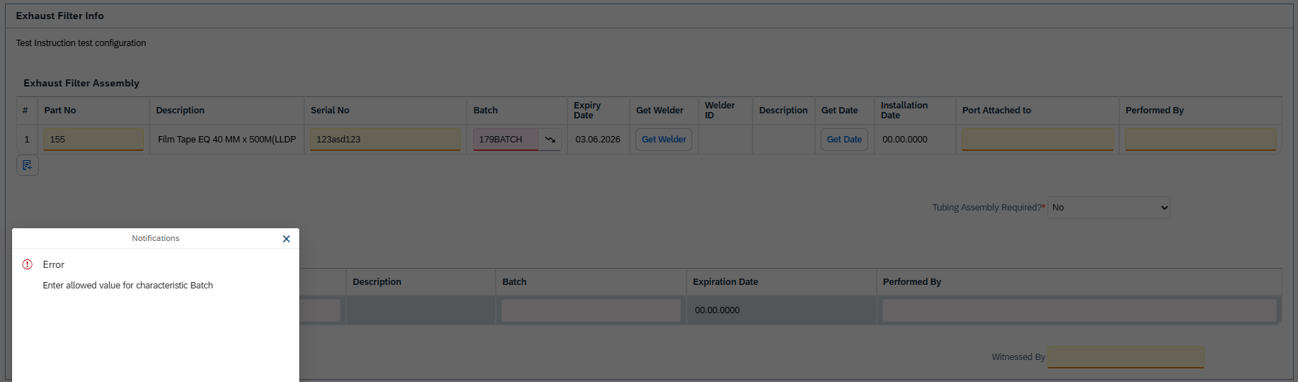

11. 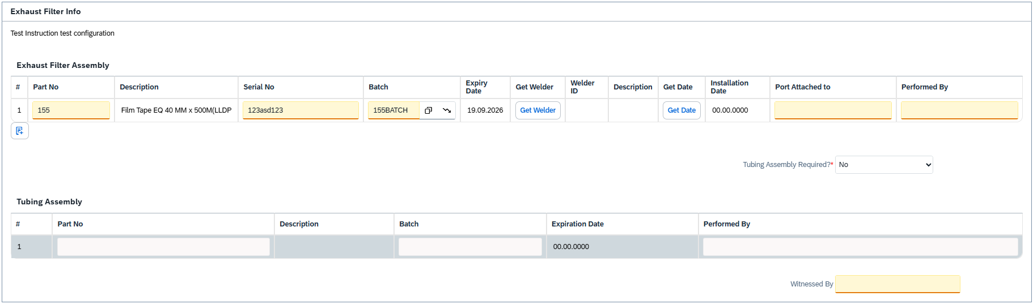

12. 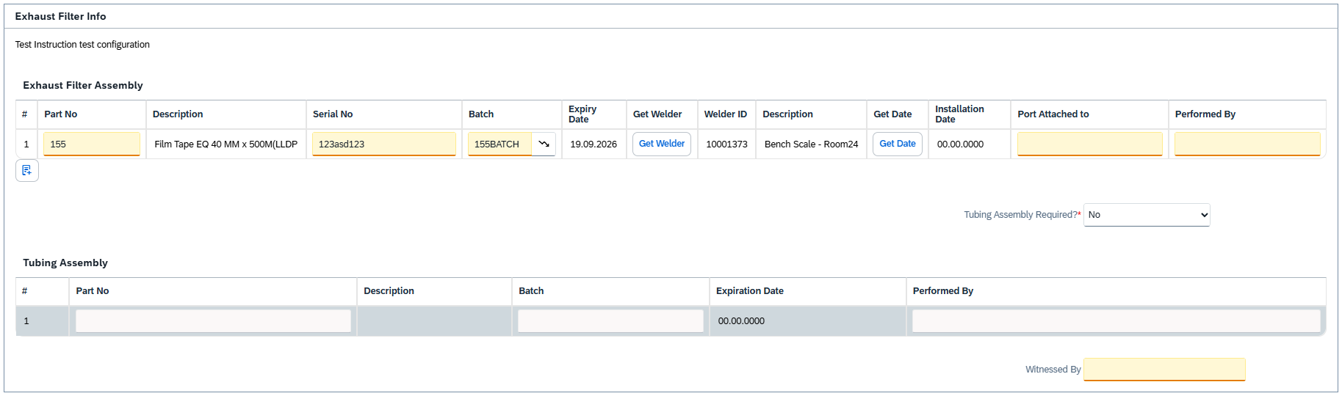

13. 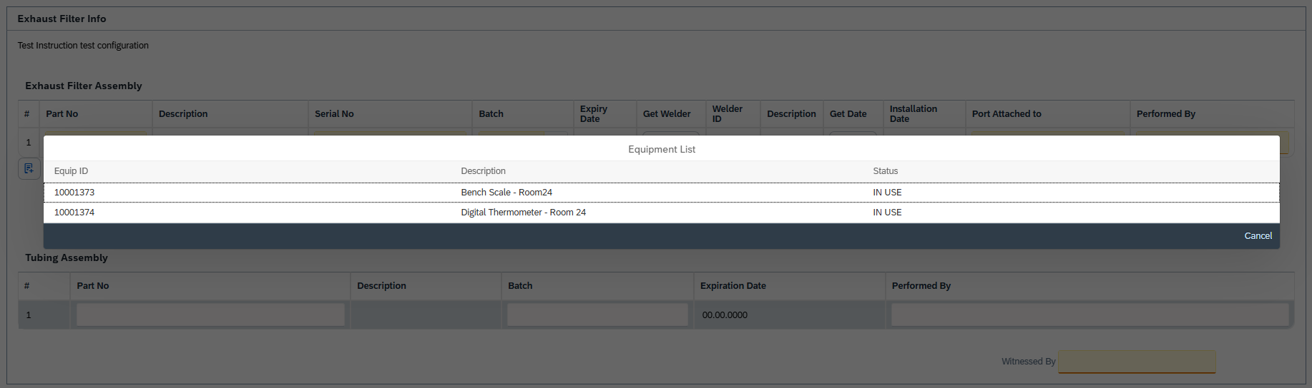

14. 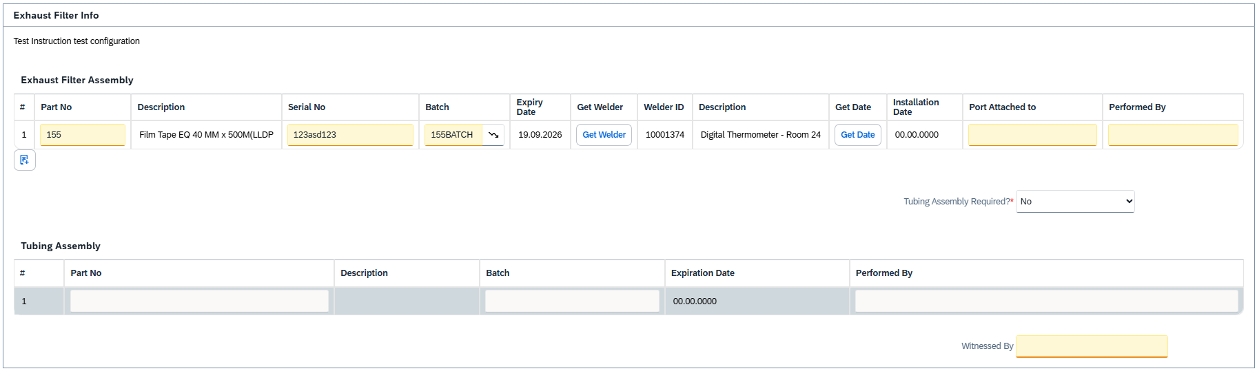
15. 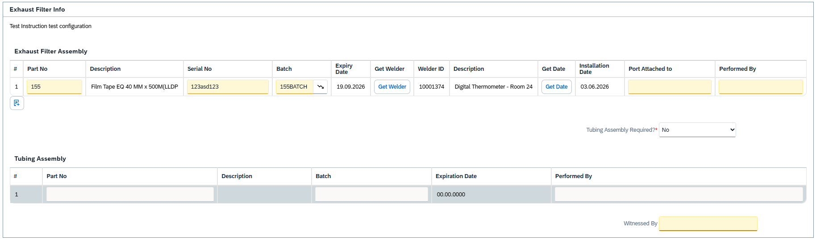
16. 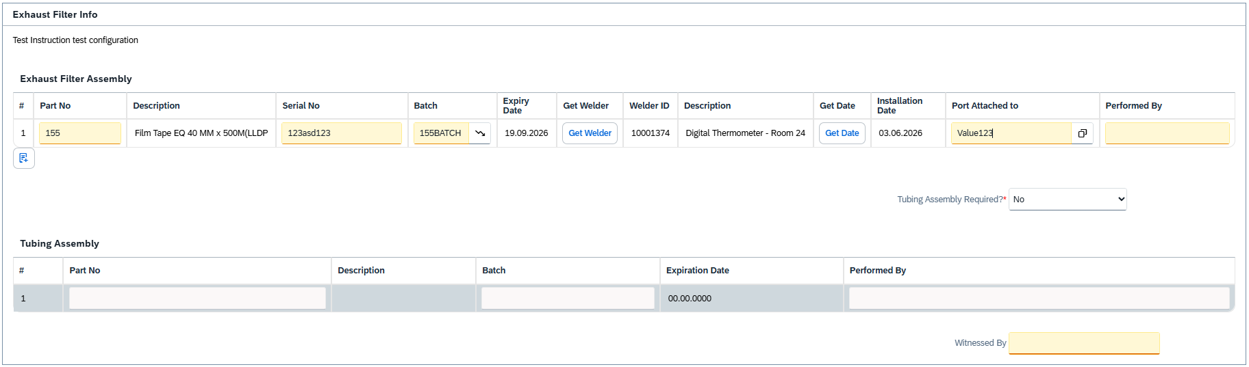
17. 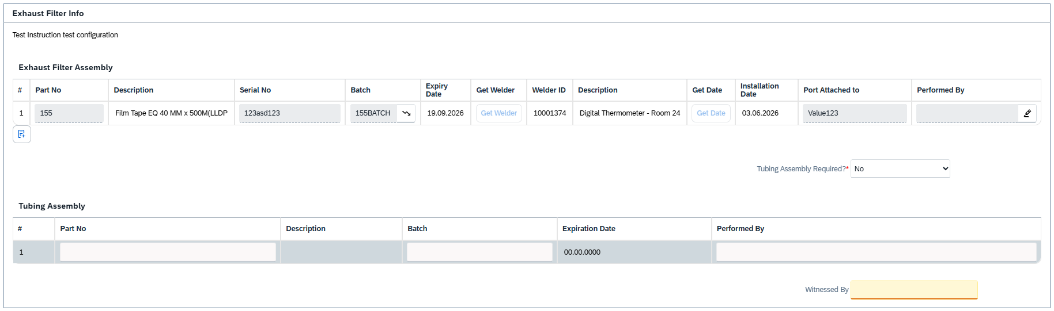
19. 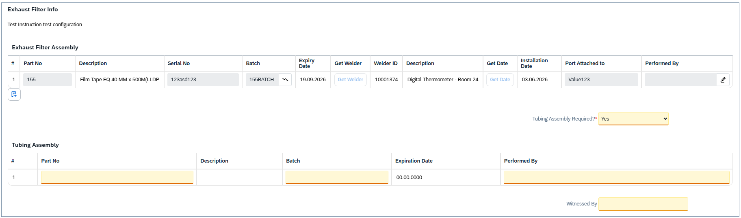
20.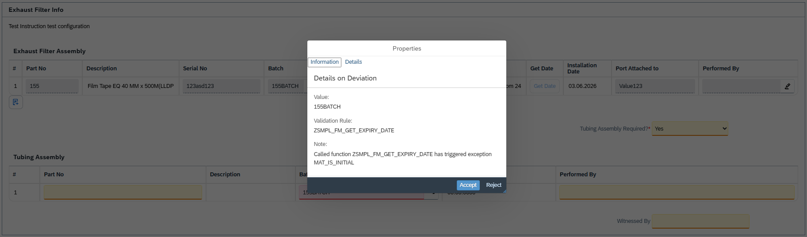

22. 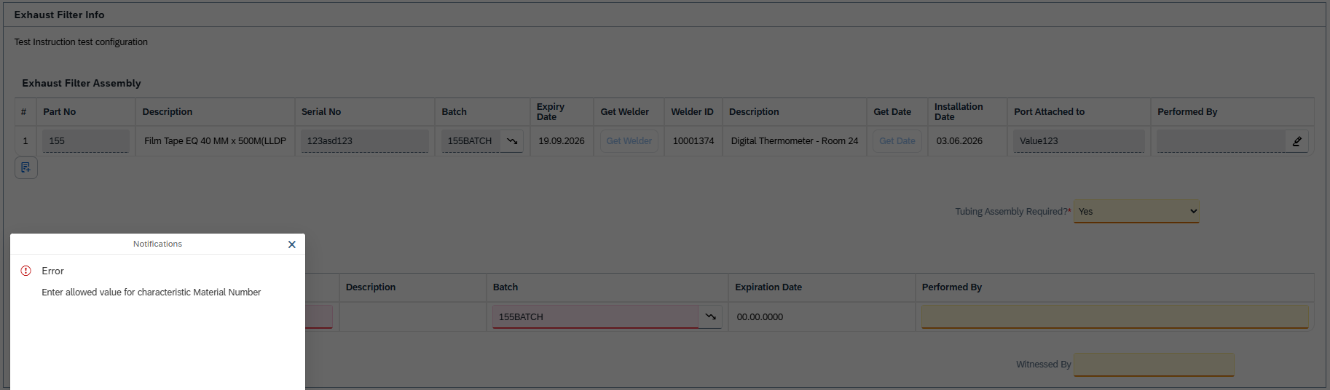

24. 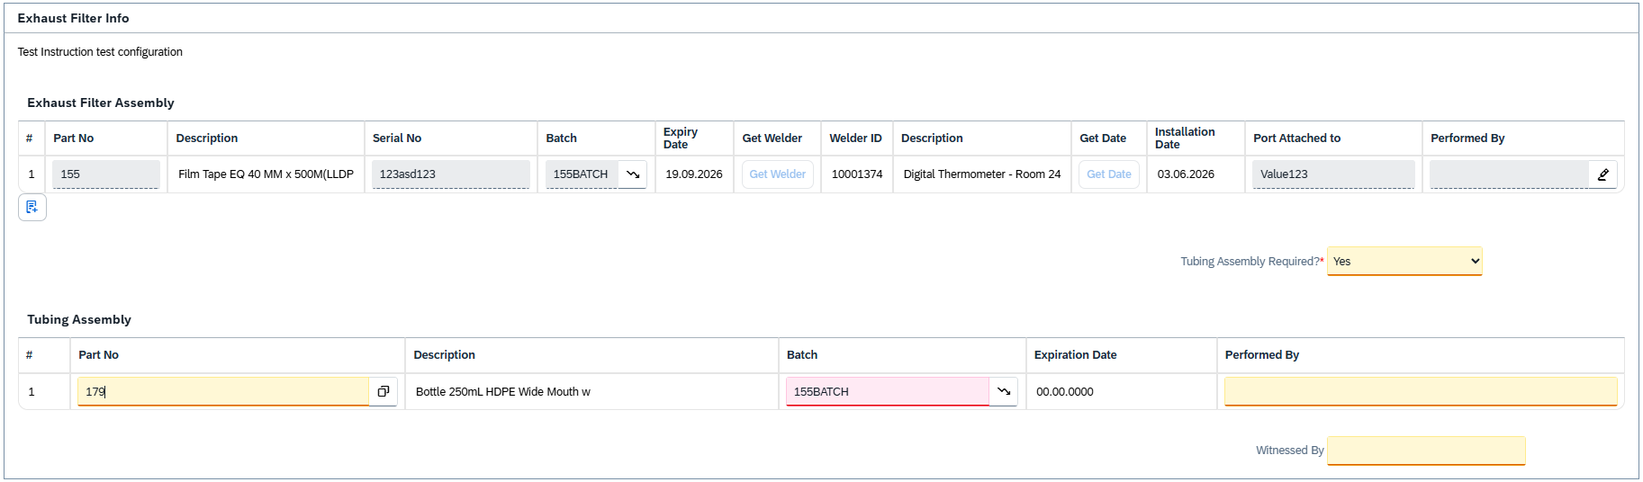
25. 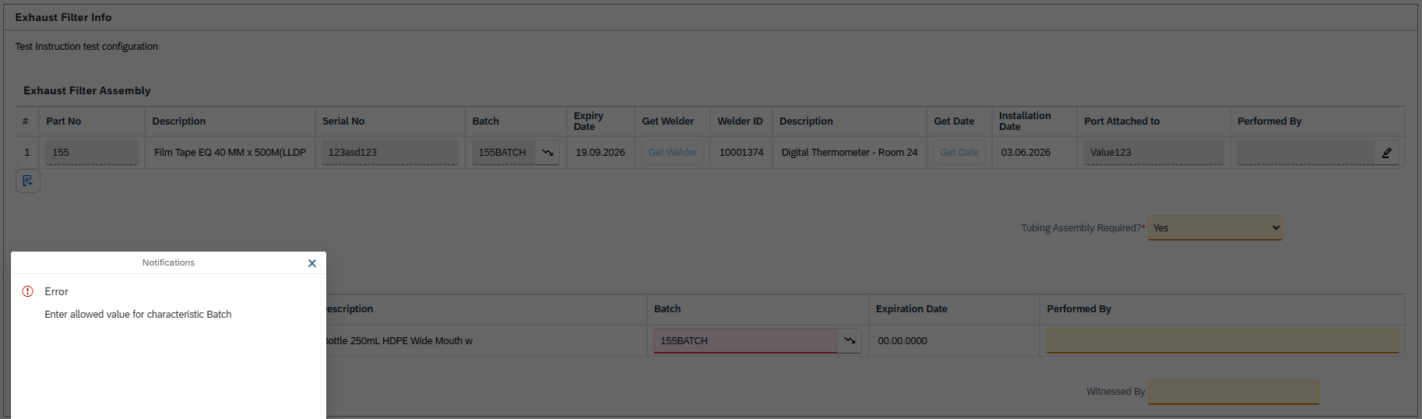
27. 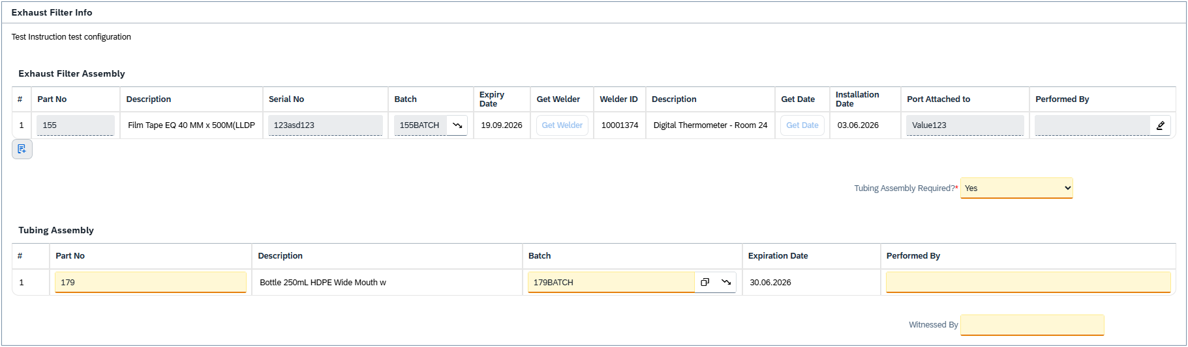
28. 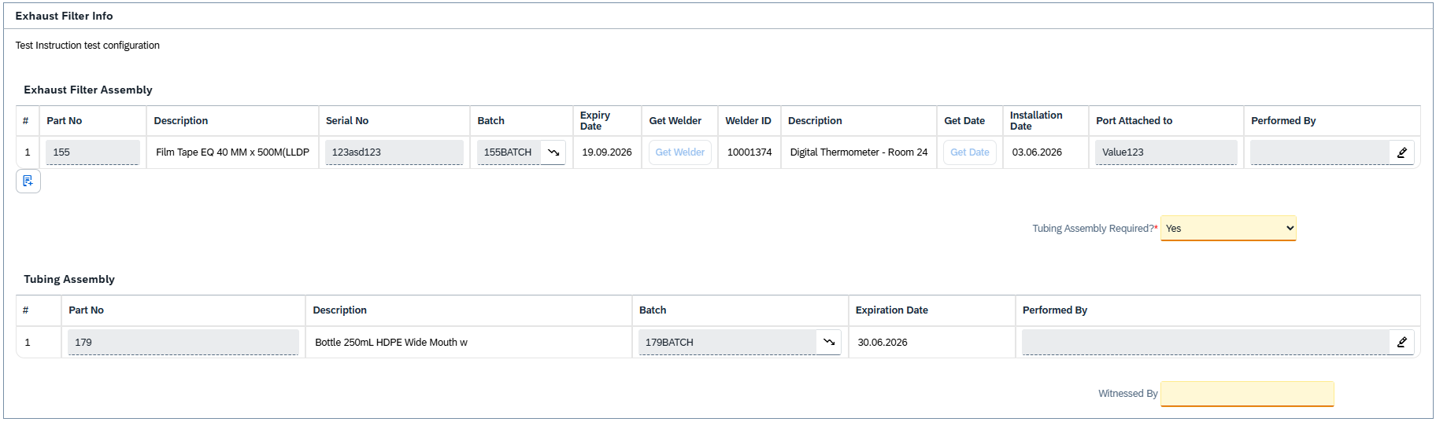
29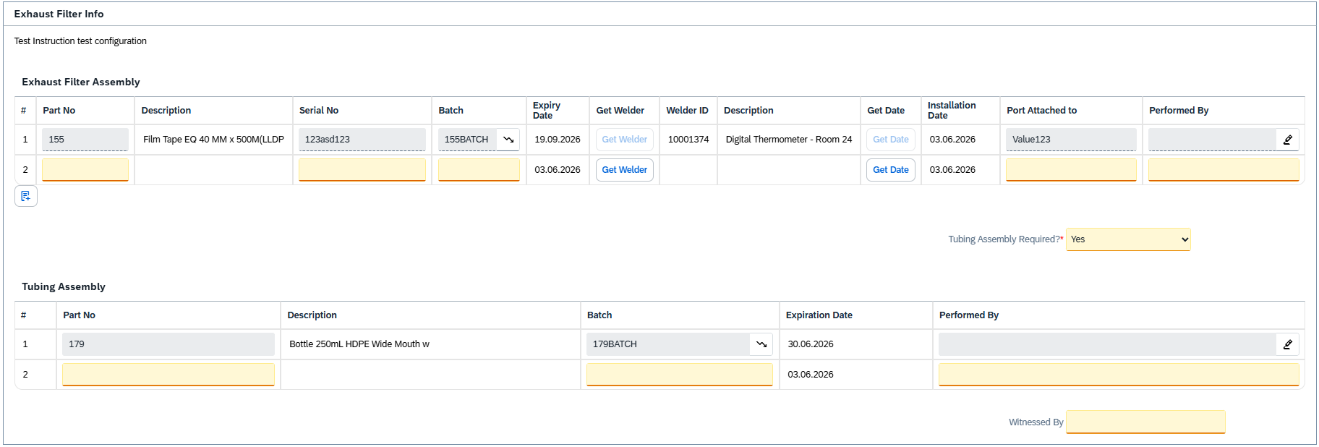
30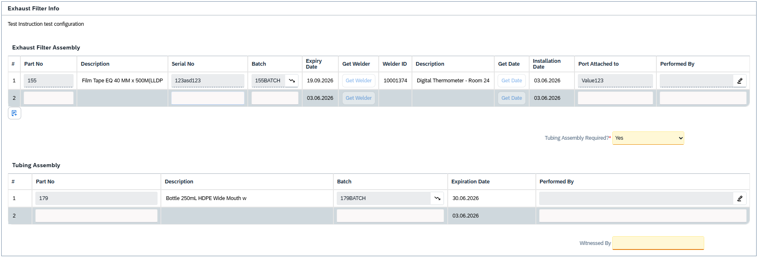
31. 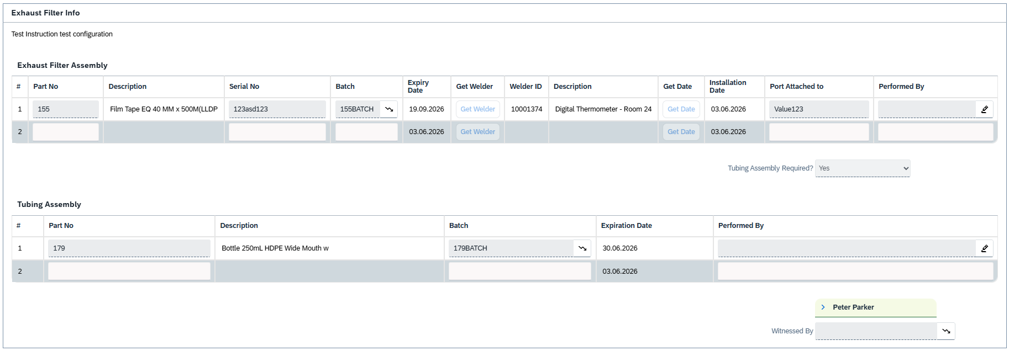

TEST SCRIPT SUMMARY RESULT
PASS/FAIL: | PASS | Comments: | NA
Signature, Initials and Date Tester 1: | Thomas Rautenbach, TR, 03JUN2026 | Printed Name  Tester 1: | Thomas Rautenbach | Executed Steps | 31
Signature, Initials and Date Tester 2 (if used): |  | Printed Name  Tester 2 (if used): |  | Executed Steps
Signature, Initials and Date Tester 3 (if used): |  | Printed Name  Tester 3 (if used): |  | Executed Steps
Signature and Initials Witness  (if used): |  | Printed Name Witness (if used):
Total Number of Test Issues Recorded for Test Script: | 0 | Total Number of Pages Attached: | 0
Approver Signature and Date: | Sign to confirm you have approved the completed Test Script and agree with the results and findings | Approver Comments
Printed Name of Approver:
Second Approver Signature and Date (if applicable): |  | Approver Comment (if applicable)
Printed Name of Approver:
The above table shall be filled in by the tester(s) and approvers following execution of the test script

